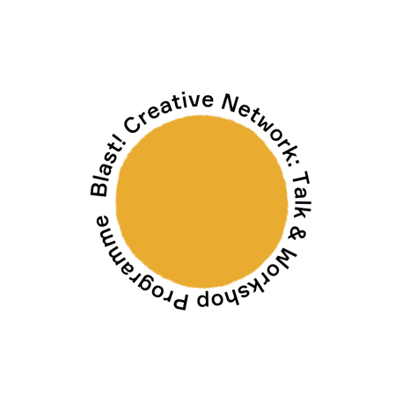
Blast! Creative Network: Online Residency Proposal

Blast! Creative Network is a group of artists and creatives which evolved out of the Multistory Blast! Festival 2019 and is growing steadily. Taking place once a month, the BCN programme offers talks, workshops, opportunities and social events to bring local emergent artists a year-long events programme that provides a space for knowledge sharing and support. We offer members the opportunity to test out new ideas and platform their work through our Online Residency space on our website, as well as on our social media channels.

Online Residencies can last for up to 1 month and will be promoted on our social media channels, and Instagram / Stories takeovers can take place for up to 3 days at a time. We accept proposals for individual as well as collaborative projects.

You can share images, text and audio/visual work as part of your residency, so feel free to be creative. Ideas for content are: images, film, recordings, podcasts, creative writing, articles, research, PDFs. Once we receive your proposal, we’ll be in touch to discuss your project further.

To apply for an Online Residency, please fill in this form and return it to jesspiette@multistory.org.uk, with a few examples of your work, if you can, using ‘Online Residency Proposal’ in the subject line. By giving us your contact details, you agree to us contacting you about your proposal(s). We will not share your details with any third parties. Our privacy policy can be found on our website https://multistory.org.uk/privacy-policy/

Name(s):

Postcode(s):

Email(s):

Website/social media channels:

Social media handles and hashtags:

Bio(s) (up to 200 words per person):

Brief description of your proposed residency / Instagram takeover, (including what your idea is, the structure/ timeline for sharing your work).

