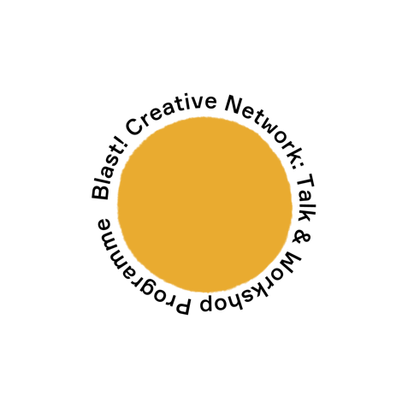
Blast! Creative Network: Membership Application

Blast! Creative Network is a group of artists and creatives which evolved out of the Multistory Blast! Festival 2019 and is growing steadily. Taking place once a month, the BCN programme offers free talks, workshops, opportunities and social events to bring local emergent artists a year-long programme that provides a space for knowledge sharing and support.

We invite art practitioners, curators and community groups to speak about a range of subjects designed to help local emergent artists and creatives to develop their practice. We also offer members the opportunity to test out new ideas and platform their work through our Online Residency space on our website, as well as on our social media channels.

Membership is free, and the programme is open to emergent artists and creatives based in Sandwell and the Black Country, from all practices, backgrounds and ages. Participants from Birmingham may also be considered if they live within one mile of our office in West Bromwich (B70 8DY).

Events usually take place at West Bromwich Town Hall but, due to current Covid-19 restrictions, all events will take place on Zoom until further notice.

To apply to become a member, please fill in this form and return it to jesspiette@multistory.org.uk, using ‘BCN Membership Application’ in the subject line.

By giving us your email address, you agree to us adding you to our Excel spreadsheet database to receive e.newsletters and other e.communications. We will not share your details with any third parties. Our privacy policy can be found on our website https://multistory.org.uk/privacy-policy/

Name:

The town / city you are based, including your postcode:

Email:

Website/social media channels:

Bio

Tell us a bit about you, your practice / interests:

